Maa Kash-chid Dukha Bhaag Bhavet!!

May no-one ever have any grief!!

Dear Investors,
The biggest currency in the world being health right now, we wish you all good health, physically as well as mentally. The latter is becoming as important as the former, as this maybe the new normal!!
Is this the new normal? This is the hottest topic of discussion and biggest question of every silent voice. Clearly COVID-19 has proved to be far more resilient than expected and any vaccine to be available to the masses will take at least a year if not more. The indomitable spirit and survival instinct of us humans is driving us to adapt to the evolving conditions, learn to coexist with the virus and also to thrive as well. The urgency and the intent to overcome and reclaim our lives and livelihoods can be amply seen in human behaviour all around us. We strongly believe that environment and the economy would bounce back to normalcy over a period of time. On the other hand, equity markets is a different story. We had been very positive on the markets for the last 6 months and strongly believed that the market correction had provided a decadal opportunity for wealth creation. However, the sharp bounce back in general equity asset prices now are factoring in a much sharper and swifter economic recovery than is likely!!
Over the past six months and two newsletters alone, we have seen equity markets globally fall 35% and then recover 50% from the bottom. Economies the world over moving from a tepid growth to complete lockdown to gradual and cautious getting back to business. During this period however, global liquidity and money injection has gone up tremendously and that is one factor which is very difficult to take back. Never, in our history have we seen liquidity being taken out of the economies as they have their own set of complications. The implication of this huge amount of liquidity sloshing around globally is that it amplifies asset market cycles both in terms of the extent of rise or fall as well as the time taken to reach there. As discussed in our June 2020 newsletter, this time we believe that since money has been given in the hands of corporates and individuals, it will flow into the real economy, maybe with a lag. However, in the near term it seems that liquidity has flown into the financial asset markets globally and distorted them in the short term. If we look at valuations of FAANG stocks in US or Reliance/Chemicals/IT or large caps stocks in India, it clearly indicates a deviation from the economic realty on the ground while stocks may have moved up ahead of the fundamentals.
Sharp market bounceback: valuations running ahead of fundamentals despite uncertainties
This brings us to our equity market view that in the near term markets appear to have moved up ahead of the fundamentals and are divergent from the economic reality. We believe that in the near term uncertainties abound globally to warrant a cautious outlook:
- Economies opening but demand not catching up: While various industries and sectors are now gradually opening up, supply chains are normalising, shops and consumption centres are allowed to function, however, we find that single biggest thing missing is consumers, which are still being cautious both in terms of venturing out too much as well as spending. We believe that psyche will only normalise once the vaccines come and are widely available and people are certain about their future.

- 2nd wave of COVID-19 pandemic leading to renewed lockdown scare: India has clearly demonstrated that lockdowns only help in temporarily delaying the inevitable or providing more time at best. Still, due to renewed surge in COVID cases in some of the western countries in what is called a second wave of the pandemic, there are renewed fears of lockdowns further adversely impacting economies.

- Uncertainty surrounding US presidential elections: While, the US presidential elections do matter in deciding the course of the world economy, they have become especially important given the current pandemic times and the challenged economic environment. The economic policies that each would follow, US-China trade wars, resolution on the fiscal stimulus would matter a lot in deciding the future course of the economies and markets globally.

- Further fiscal stimulus in US and globally: The global and US economies are not out of the woods yet and are still struggling to stand on their feet. The single biggest risk facing the economies today is the premature withdrawal of fiscal stimulus which would severely impact the economic recovery which is still in its infancy.
We believe that these uncertainties become even more relevant when the market valuations on trailing PE and PB basis are almost back to pre-covid level and growth in the near term is uncertain. Low volatility Index (VIX) further implies complacency and higher risk appetite in the minds of investors, quality of stocks going up is questionable. Many of the companies are now trading at valuation multiples far in excess of their long term averages or not in consonance with their prevailing macro environment. Markets have a tendency to overreact both in times of exuberance and excessive pessimism and the same seem to be happening currently as well. It’s also in the nature of markets to mean revert like an oscillating pendulum and on most previous occasions whenever equity markets have traded at these valuations, they have generated negative returns in the near term. We thus believe that there is high likelihood of the market and stocks taking a breather in the near term.

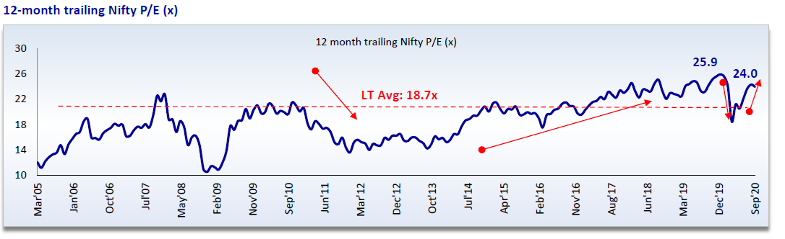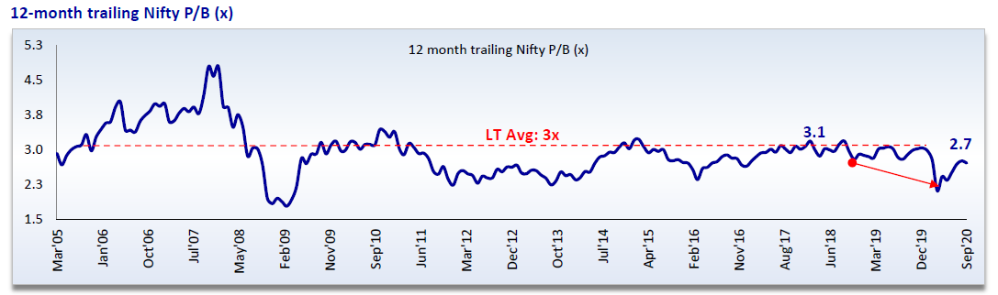
Outlook and recommendation:
While markets have moved up quite sharply, there are still pockets of opportunity available that are attractive and provide value hunting opportunities. We believe that there is still lot of value on offer in the BFSI, metals and Midcap space:
- BFSI: BFSI has significantly underperformed NIFTY and is down 33% CYTD. This is also indicated by sharp 870 bps reduction in BFSI weight in NIFTY from 42% in Dec’19 to 33.8% now. From these levels of valuations there is opportunity for significant value creation though would be accompanied with volatility.

- Metals: Metals are trading at 1 standard deviation below their mean valuation and also below their book values. These valuations were last seen 10 yrs back and offer opportunity for significant value creation. Being a global cyclical, volatility is high.

- Midcaps: Midcap space again has been a significant underperformer since the last 3 years and the market cap in the space is still down 25% from their peak in Dec’17. We believe that there are quite a few good quality companies to be picked up in this space and create value.
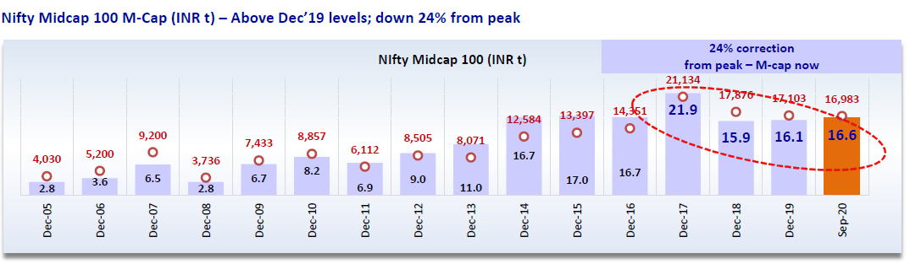
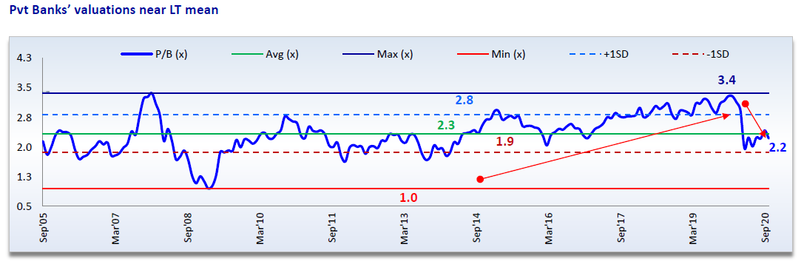
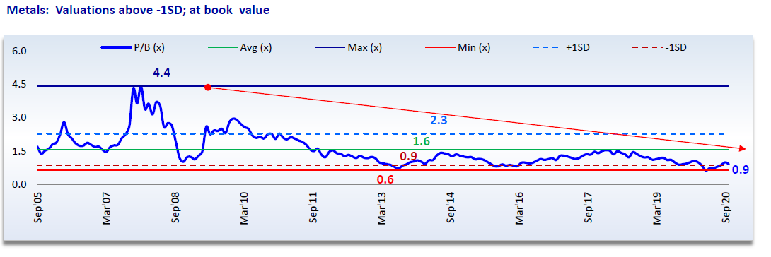
With markets having moved back up sharply, we believe that easy money that the equity markets were offering 2 quarters back is clearly off the table and going forward it would be more of bottom up stock picking which would deliver superior returns. One needs to keep in mind that volatility is here to stay as uncertainty around US elections, 2nd wave of COVID-19 pandemic, uncertainty around continued fiscal stimulus and the impact of covid on demand remain.
It is difficult to pin point the top and bottom but stocks seem to have gone into overbought zone, valuations on trailing PE and PB basis are back to pre-covid level and demand in the near term is uncertain. Low volatility Index (VIX) further implies complacency and higher risk appetite in the minds of investors, quality of stocks going up is questionable. Many of the companies are now trading at valuation multiples far in excess of their long term averages or not in consonance with their prevailing macro environment. Hence it is recommended to gradually increase equity allocation from heron and invest in good companies slowly on every decline keeping in mind that recovery will take time and there will be mean reversion in the long term.

Green Lantern Capital Alpha Fund’s Investment Performance:

In the end we want to share the investment performance of your funds. Over the last few quarters, given the heightened volatility and uncertainty, we have actively allocated funds to large cap companies and quality mid-caps, as it made eminent sense from risk-reward perspective. Sector exposure was also actively allocated to metals, IT, BFSI depending upon outlook and value. The same has benefitted your funds immensely. We have now increased cash levels in the funds, as well as increased exposure to BFSI and other sectors and stocks that continue to offer value.

We are extremely happy and proud to report that given our investment approach of focus on high quality companies with high margin of safety, even during the peak drawdown of the market your funds in Green Lantern Capital Alpha Fund outperformed the market by a wide margin.

It was also heartening to see that even during market recovery, your funds moved up sharply, more than recovered the drawdown and delivered a healthy return with strong outperformance over benchmark.

